A
PROJECT REPORT
ON
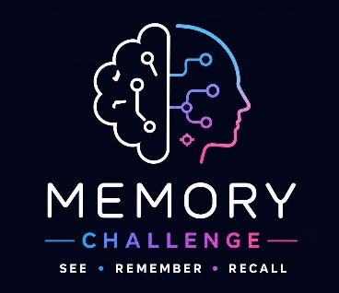

(Memory Challenge Game)

SUBMITTED BY

Mahek M. Lalwani

ACADEMIC YEAR 2026-27
T.Y B.C.A SEM -5

UNDER THE GUIDANCE OF

Mr. YASH KOTECHA

SMT. C.Z.M GOSRANI B.C.A. COLLEGE
JAMNAGAR

SUBMITTED TO

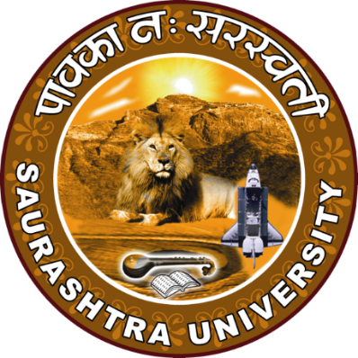

SAURASHTRA UNIVERSITY
RAJKOT

